Harmonic Balance Method

Project #1

7 December 2015

Daniel Clark

Mackenzie Kirby

Utsav Parmar

Soumith Vodnala

**Introduction**

Nonlinear vibrations and oscillations pose difficult problems in many engineering and biological systems that make simulating the responses challenging. The challenges associated with nonlinear response can include: responses at both the forcing frequency and additional frequencies; driving at fractions of the natural frequency resulting in residence; bifurcations of the response resulting in multiple solutions at the same setting; and chaotic responses as a result of nonlinear coupling. Theses challenges make the study of the response of nonlinear systems extremely critical within the entire operating domain. However, many systems have a wide operation range making it computationally impossible to evaluate the response under every setting. It is possible to overcome this limitation utilizing transformation methods that allow for the approximation of the differential equations as algebraic expressions. In this study the method of Harmonic Balance is utilized to approximate the response of various linear and nonlinear steady-state responses.

**Theory**

The Harmonic Balance method is an example of a perturbation method capable of approximating the steady-state solution of a response given the forcing function is harmonic and response is conservative. The solution of the response is expressed as a Fourier series truncated to a desired number of terms as:

$x\left(t\right)=a_{0}+\sum_{n=1}^{N}{\left(a_{n}\cos\left(nωt\right)+b_{n}\sin\left(nωt\right)\right)}$ (1)

Where N is the order of truncation, ω is the angular frequency with the time period T, an and bn are the Fourier coefficients. Substituting Eq. 1 into the system’s equation of motion (EOM) the Fourier coefficients can be determined by solving the resulting algebraic expression. The accuracy of this method depends on significantly on the number of harmonics included in the approximation. This is especially true as the forcing function becomes more complex. However, as the number of terms increases the computational time and effort may become overwhelming. This is further amplified if the driving frequency of the function is unknown, adding the angular frequency to the number of coefficients to be solved for.

In this study the Harmonic Balance method is accomplished numerically utilizing samples of the steady-state response collected evenly. Then applying the Fast Fourier Transform (FFT) algorithm utilizing Python in the frequency domain. The details for which can be found in the following section, followed by two simple linear verification cases and three non-linear cases.

**Format of Harmonic Balance Subroutine**

The subroutine for finding the harmonic balance response begins by creating a ‘sampled frequency’. This involves defining the number of samples the user wishes to take and creating a vector of evenly spaced positions in time. For this analysis, it was determined that we could guess an initial response function which is equal to the forcing function. Therefore *xbar* is set equal to the forcing function which is in turn a function of the time vector.

*N = 99*

*t = np.linspace(0, 10*np.pi, N+1) # Time sample vector*

*t = t[0:-1] # Removing the extra sample*

*f = np.cos(2*t) # My forcing function*

*T = t[-1]*

*xbar = f #Initial guess of the response function*

The second step in the analysis is to put the response function into the form of a periodic response using fast Fourier transforms and to calculate the remainder, *R*, when the results are plugged into the original differential equation. This step is incorporated into a subroutine within the process.

*def FUNCTION(xbar):*

*N = len(xbar)*

*Xbar = np.fft.fft(xbar) #Calculate the fft of xbar*

*omega = np.fft.fftfreq(N, T/(2*np.pi*N) ) # list of frequencies*

*dotxbar = np.fft.ifft(np.multiply((1j*omega),Xbar)) #Calculate the derivative of xbar*

*dotdotxbar = np.fft.ifft(np.multiply((1j*omega)**2,Xbar)) #Calculate the derivative again*

*R = dotdotxbar + dotxbar + xbar - 0*xbar**3 – f #Substitute into original eqn*

*R = R**2*

*R = np.sum(R) #Calculate the remainder*

*return R*

After the function calculating the remainder has been defined, it can be inserted into a ‘minimize’ function and the response of the system can be optimized with respect to the remainder. The results of this minimize function are the output of the harmonic balance method.

*optimizedResults = sci.minimize(FUNCTION, xbar, method='SLSQP')*

*xbar = optimizedResults.x*

*print(optimizedResults)*

*print(xbar)*

*pl.scatter(t,xbar)*

*pl.show()*

**Verification Code Using linear functions**

To ensure the Harmonic Balance subroutine was functioning properly and approximation of the steady-state system response would be accurate for complex nonlinear responses the code was verified using 2 simple linear cases. The two case were are shown below:

*Linear undamped system*

$\ddot{x}+x=\cos{(2t)}$ (2)

*Linear damped system*

$\ddot{x}+\dot{x}+x=\cos{(2t)}$ (3)

The solutions of their respective steady-state response are simple closed form equations. This allows for the calculation of the exact error. The linear undamped response and linear damped response are shown in Eq. 4 and 5 respectively.

$x\left(t\right)= \frac{-1}{3}\cos{(2t)}$ (4)

$x\left(t\right)= \frac{2}{13}\sin\left(2t\right)- \frac{3}{13}\cos{(2t)}$ (5)

A graphical comparison between the analytical solution and the Harmonic Balance approximation for both cases are found below. The Harmonic Balance approximation is built utilizing 100 samples and is represented by discrete points on the plots. The root-mean-squared error for the linear undamped case is 0.0168834 and 0.0133163 for the damped case. From this simple study the code is deemed stable and is assumed accurate for nonlinear system responses.

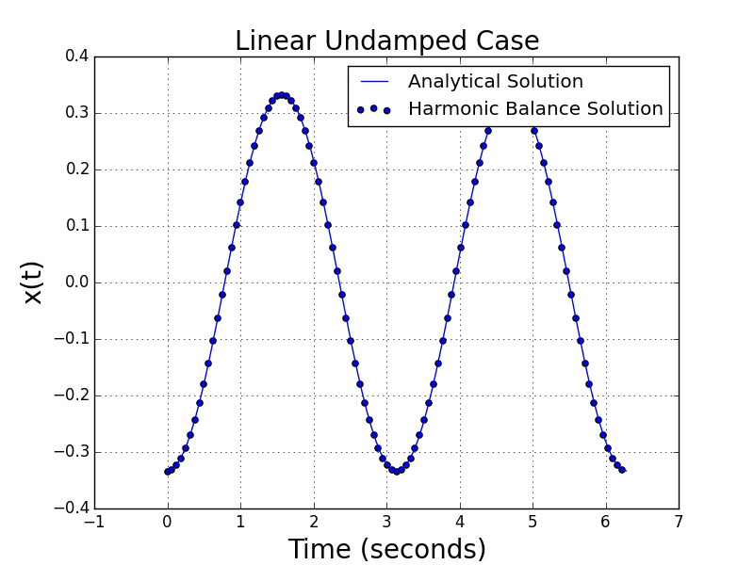

Figure 1: Comparison between the analytical solution and the Harmonic Balance solution

Linear damped Case

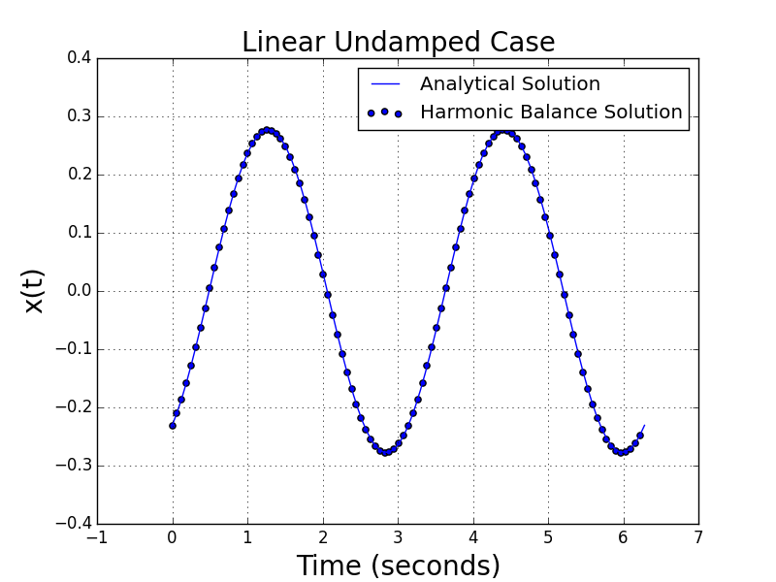

Figure 2: Comparison between the analytical solution and the Harmonic Balance solution

**Nonlinear Results**

For this project, three functions were evaluated with the harmonic balance function defined above. These functions are shown below:

*The Duffing Oscillator*

$$\ddot{x}+\dot{x}+x+x^{3}=A*cos⁡(ωt)$$

*The Nonlinear, Damped Pendulum*

$$\ddot{x}+\frac{ζ}{m*l}\dot{x}+\frac{g}{l}\sin\left(x\right)=A*cos⁡(ωt)$$

*The Van der Pol Oscillator*

$$\ddot{x}-μ\left(1-x^{2}\right)\dot{x}+x=A*cos⁡(ωt)$$

The time response of each of these functions was found using both an integration function and the harmonic balance method. The results are compared with respect to both the qualitative and quantitative difference between the signals. These results are discussed below. When considering simulation time, the harmonic balance method solved within a few minutes in each case where the integration function solved almost instantaneously. However, the time taken to solve for the harmonic balance method response was never so significant as to be considered computationally expensive. Giving preference to the integration function on the basis of simulation time alone would yield diminishing returns. However, this conclusion may need to be reevaluated as the complexity of the system increases.

*The Duffing Oscillator*

When plotted together, the two responses for the duffing oscillator are qualitatively very similar. There is a transient component in the integrated solution which does not appear in the harmonic balance response. However, it disappears after approximately the first cycle. It should also be noted that there is a phase shift in the response which both methods capture. The Root Mean Square Error (RMSE) between the two signals for the specified time sample is 0.0381. As a percentage of the RMS of the integrated solution, the error is 15%. It is reasonable to assume that this value would decrease slightly as time goes to infinity and the effect of the transient response becomes relatively small.

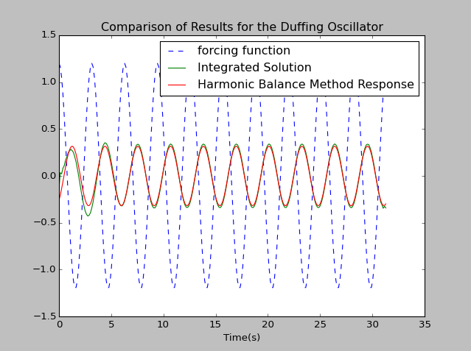

Figure 3: Calculated result comparison for the Duffing Oscillator (RMSE = 0.0381)

Overall, the harmonic balance method provides an acceptable approximate response for the sustained behavior of this system.

*The Nonlinear, Damped Pendulum*

Compared to the Duffing oscillator, the nonlinear, damped pendulum has a much larger transient response. For the time sample shown below, the RMSE is 0.310 and the percent error is 46%. Despite this, the two responses are again qualitatively similar towards the end of the time sample.

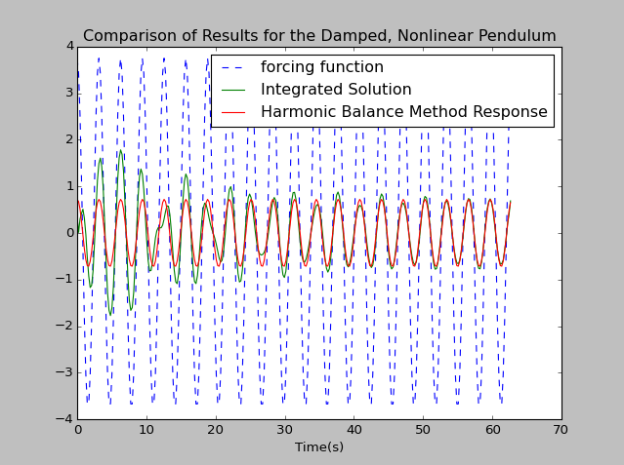

Figure 4: Calculated result comparison for the nonlinear, damped pendulum (RMSE = 0.310)

When the time sample was doubled, the percent error decreased from 46% to 37%. Although the increase in sample size did reduce the error by about 10%, such a value for error is still significant and may not be appropriate for engineering specifications.

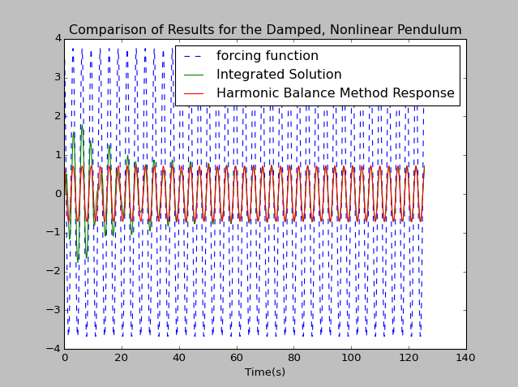

Figure 5: Calculated result comparison for the nonlinear, damped pendulum for a longer period of time (RMSE = 0.219)

It is important to note that the harmonic balance method only captures the harmonic response of the system. This has already been observed by the lack of transient response in the signals. The additional significance for the nonlinear, damped pendulum is fact that behavior such as the pendulum performing a complete revolution would not be captured. Therefore, the user must set the magnitude of the forcing function low enough as to not induce this behavior.

*The Van der Pol Oscillator*

The RMSE for the Van der Pol oscillator was equal to 2.08 and the percent error equal to 130%. This is obviously an incredibly large error the causes of which can be seen in Figure 4 below. Most apparent is the difference in amplitude between the two responses. In fact, this difficulty in reaching the correct amplitude has been observed with the Duffing oscillator and the nonlinear, damped pendulum as well. It is necessary for the approximated solution to be close to the calculated solution in order to obtain the correct result. An additional cause of error is the fact that the frequency of the response did not change from that of the forcing function; the integrated solution has a frequency of approximately two thirds the forcing function. Although the harmonic balance method did obtain the qualitative shape of the response, the amplitude and frequency differences create an error which is too large to be considered acceptable.

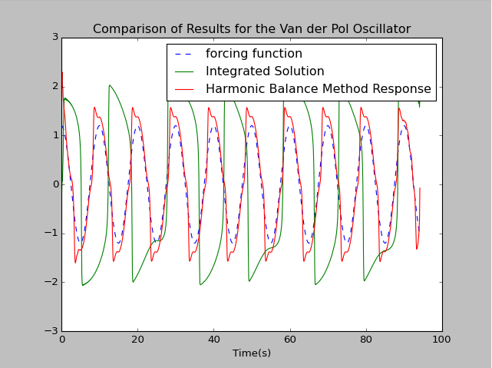

Figure 6: Calculated result comparison for the Van der Pol Oscillator (RMSE = 2.08)

**Conclusions**

Although the performance of the harmonic balance function was acceptable for one of the tested systems, the percent error was too large for the remaining equations. Additionally, the inability to approximate amplitude or shift to the correct frequency are not acceptable errors. If the harmonic balance function is to be used, either its deficiencies much be well known to the engineer or the function must be improved to a level beyond the scope of this course.